**OpenSSL s_server Example**  
  
  
**Note**: A cert and key must be specified. Therefore, in the current directory I have included a cert and key extracted from a self-signed JKS that can be used for this.  
  
Here’s that command again:  
C:\>C:\cygwin\home\jcdc\Github\CW_Tools\tools\openssl\OpenSSL-Win32_1_0_2h\bin\openssl.exe s_server -accept 4443 -WWW -cert c:\tmp\cert.pem -key c:\tmp\key.pem  
  
…then you can view files using a web browser…

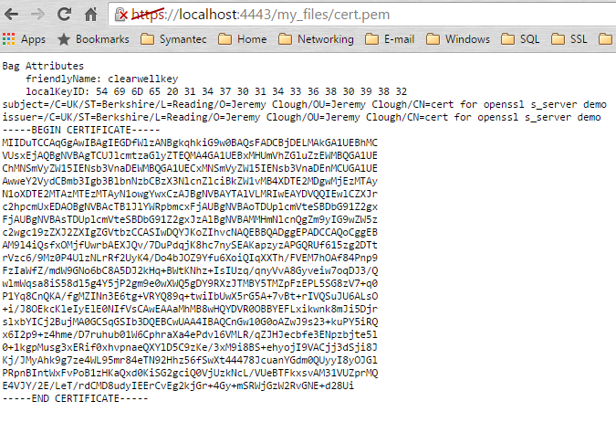  
**NOTE #1:** One, major limitation is that the server always looks under the OpenSSL directory for the source files. For example, for the example above, OpenSSL looks for this file:C:\cygwin\home\jcdc\Github\CW_Tools\tools\openssl\OpenSSL-Win32_1_0_2h\my_files\cert.pem  
  
**NOTE #2:** You must specify an explicit file, i.e. you cannot just specify a directory. OpenSSL is therefore not really useful as a general file server.  
  
Below is the error you see when OpenSSL cannot find the file requested:  
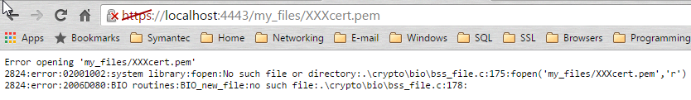  
  
*JeremyC 2/8/2016***END**